DHCP configures a client with:

When a PC connects to a DHCP server, the server assigns or leases an IP address to that PC. The PC connects to the network with that leased IP address until the lease expires. ***The host must contact the DHCP server periodically to extend the lease.***

IP address

Gateway address

Subnet mask

DNS server address

Other info: Domain name

DHCP Operation:

DHCPDISCOVER initiated by client (Layer2 Broadcast):

Src MAC = Client MAC, Src IP = 0.0.0.0

Dst MAC = ff:ff:ff:ff:ff:ff, Dst IP = 255.255.255.255

Port is UDP 67

DHCPOFFER sent by server (Layer2 unicast)

Src MAC = DHCPSrvr MAC, Src IP = DHCPSrvr IP

Dst MAC = Client MAC, Dst IP = <offered ip address>

Port is UDP 68

DHCPREQUEST sent by client to accept the offer (broadcast)

DHCPACKNOWLEDGE sent by server with complete addressing configuration (unicast)

If DHCP server is outside the network, then the default gateway for that network will need to be configured as relay agent using *the* ***ip helper-address******<ip address of server>.***

Note: a router can also be configured as relay agent for other services:

Port 37: Time

Port 49: TACACS

Port 53: DNS

Port 67: DHCP/BOOTP server

Port 68: DHCP/BOOTP client

Port 69: TFTP

Port 137: NetBIOS name service

Port 138: NetBIOS datagram service

What if the client requests are not getting to the router (dhcp service)? The presence of client DHCPDISCOVER traffic can be verified as follows using an access list:

**access-list 100 permit ip host 0.0.0.0 host 255.255.255.255**

**debug ip packet detail 100**

**Network Address Translation (NAT)**

Private IP Address Space:

10.x.x.x 255.0.0.0

172.16.0.0 thru 172.31.0.0 255.240.0.0

192.168.0.0 255.255.0.0

***Definition- socket- an ip address:socket pair e.g. 200.100.50.25:80***

Three types of NAT translation: Static, Dynamic, and Dynamic with Port-Address Translation

Static NAT uses a one-to-one mapping of local to global addresses. Static NAT mappings remain constant. Static NAT is used for servers or hosts that require a consistent address on the Internet.

Dynamic NAT uses a pool of **public addresses** and assigns them on a first-come, first-served basis.

Dynamic with Port-Address Translation – in order to keep conversations unique, the NAT service may substitute a unique port number for the source port in order to obtain a unique socket.

Important NAT Terminology:

Inside local, inside global, outside global, ~~outside local~~

How does TCP determine the source port number? ? ? ? ? ?

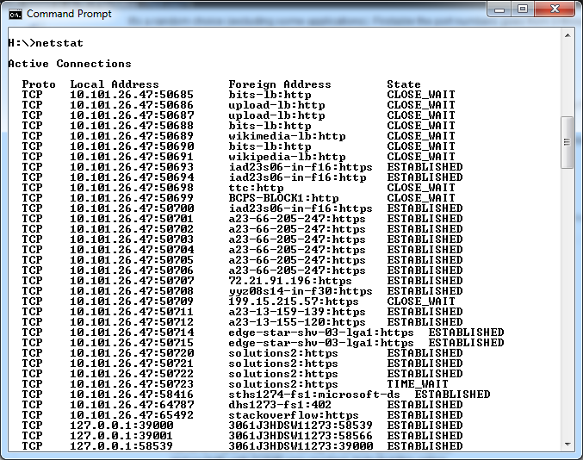

*From Cisco Learning Network:*

*Often the source port is selected by random selection. Port number range is 0-through-65535. There are three categories:*

Well-known: 0-1023

Registered: 1024-49151

Dynamic: 49152-65535

Clients usually use a non-Well-known port number.

Some applications always use the same source and destination ports numbers.